AI-Augmented Backend Development Project :
TITLE : AI Weather Wise

Project Description

In a Single Paragraph
AI WeatherWise is a modern REST API backend developed using Node.js and Express.js. The application uses MongoDB as its database, with Mongoose ODM for efficient data modeling and database operations. It retrieves real-time weather information and uses Google Gemini AI to analyze the weather data and generate useful summaries along with personalized suggestions according to the current environmental conditions.
The system provides a secure user authentication mechanism using JWT (JSON Web Token) and protects user passwords through bcrypt hashing. It also offers various API services that allow users to save and manage their preferred locations and access weather-related information. A built-in fallback mechanism helps the application remain operational when external API keys or third-party services are unavailable. Furthermore, the backend uses centralized error management and request sanitization to enhance security, reliability, and overall API performance.

Scenario
Alex is a frequent traveler who visits various cities and regions. Since weather conditions can change from one location to another, Alex needs a convenient application to check current weather information and get intelligent suggestions for planning activities according to the weather.

Problem

- Managing weather information for several preferred locations can be difficult and time-consuming.
- Standard weather applications may not provide activity or clothing suggestions based on current conditions.
- Raw weather values such as temperature, humidity, and wind speed may not be easy for every user to understand.

Solution

- AI WeatherWise solves these challenges by providing a centralized backend service for collecting weather information and generating AI-based insights. The system securely maintains user accounts and saved locations while using Google Gemini AI to transform weather data into understandable summaries, recommendations, and useful suggestions.

Usage

- Weather Monitoring: Users can check current weather conditions such as temperature, humidity, wind speed, and other environmental details for selected locations.
- AI-Location Management: Users can save and manage frequently visited or preferred locations, making it easier to access weather information whenever required.
- Based Assistance: The application analyzes available weather information and generates easy-to-understand summaries and useful recommendations through Google Gemini AI.

Outcome

- The AI WeatherWise application provides users with a simple and intelligent way to access real-time weather information and understand changing environmental conditions. By combining weather data with Google Gemini AI, the system generates meaningful summaries and personalized recommendations instead of displaying only raw weather values.
- The application also makes it easier to manage multiple locations and retrieve weather information whenever required. Secure authentication, saved preferences, and reliable API services improve the overall user experience. As a result, travelers and other users can use the system to make better-informed plans based on current weather conditions.

System Requirements :

- Software Requirements
  - Operating System: Windows 10/11, macOS, or Linux for running and developing the backend application.
  - Node.js (v16 or above): Provides the runtime environment required to execute the server-side JavaScript code.
  - npm (v8 or above): Used to install, update, and manage the packages and dependencies required by the project.
  - Express.js: Node.js web framework used to create RESTful APIs, handle HTTP requests, and manage backend routes.
  - Google Gemini AI SDK: Used to connect the application with Gemini AI for generating weather summaries, recommendations, and intelligent insights.
  - MongoDB: NoSQL database used to store user accounts, authentication information, favorite locations, and other application data.
  - Mongoose ODM: Provides schema-based data modeling and simplifies communication between the Node.js application and MongoDB database.
  - Postman: Used for testing and verifying REST API endpoints, request methods,
responses, authentication, and error handling.
  - Code Editor: Visual Studio Code or another suitable IDE for writing, editing, and managing the project source code.

Hardware Requirements
  - Processor: Intel Core i5 (8th Gen or above) / AMD Ryzen 5 or equivalent for smooth backend development and execution.
  - RAM: 8 GB minimum, with 16 GB recommended for running the Node.js server, MongoDB, development tools, and other applications simultaneously.
  - Storage: At least 1 GB of free disk space for the project files, dependencies, database components, and development tools.

Project Architecture

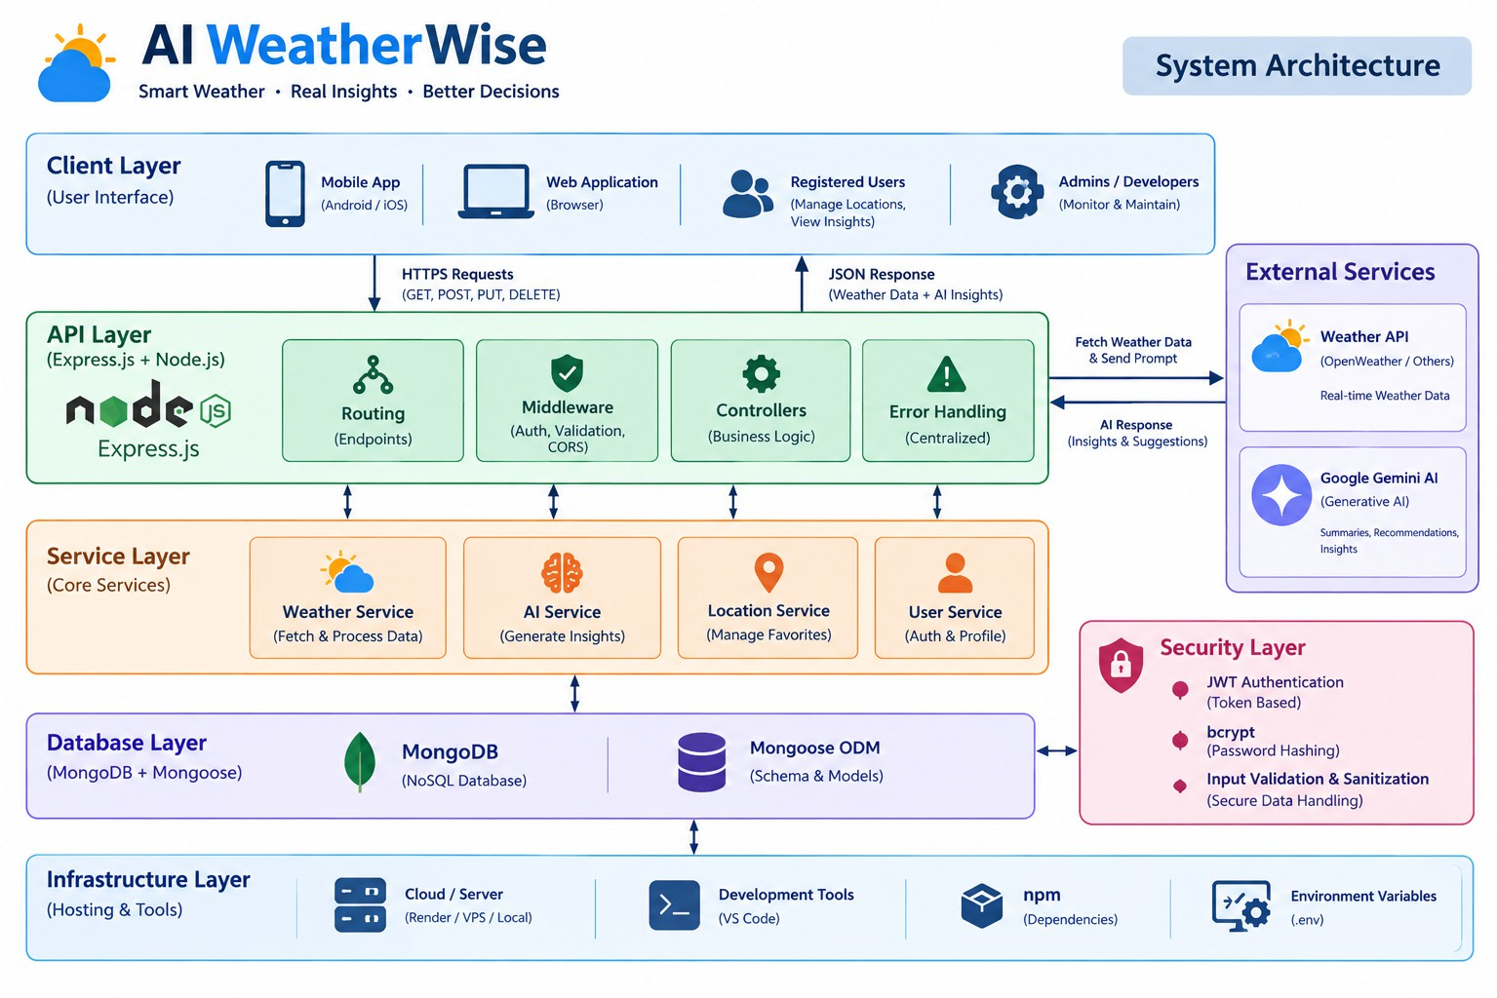
The AI WeatherWise application follows the MVC pattern to decouple business logic from data management. The Controller layer orchestrates weather fetching from OpenWeatherMap and generation of AI insights via Gemini, while the Model layer manages User and Location entities

System Components
  - User Interaction Layer: Users interact with the application through API clients or a frontend interface to request weather information, manage locations, and receive AI-generated insights.
  - API Management Layer: The Node.js and Express.js backend receives HTTP requests, routes them to the appropriate endpoints, processes JSON data, and sends structured responses to the client.
  - Authentication Module: JWT is used to authenticate users and protect private API endpoints. Passwords are securely stored using bcrypt hashing.

  - Weather Processing Module: This component communicates with the external weather API to retrieve current weather conditions such as temperature, humidity, wind speed, and other environmental information.
  - Location Management Module: Handles the creation, retrieval, updating, and deletion of users' favorite locations and maintains the relationship between users and their saved locations.

ER Diagram
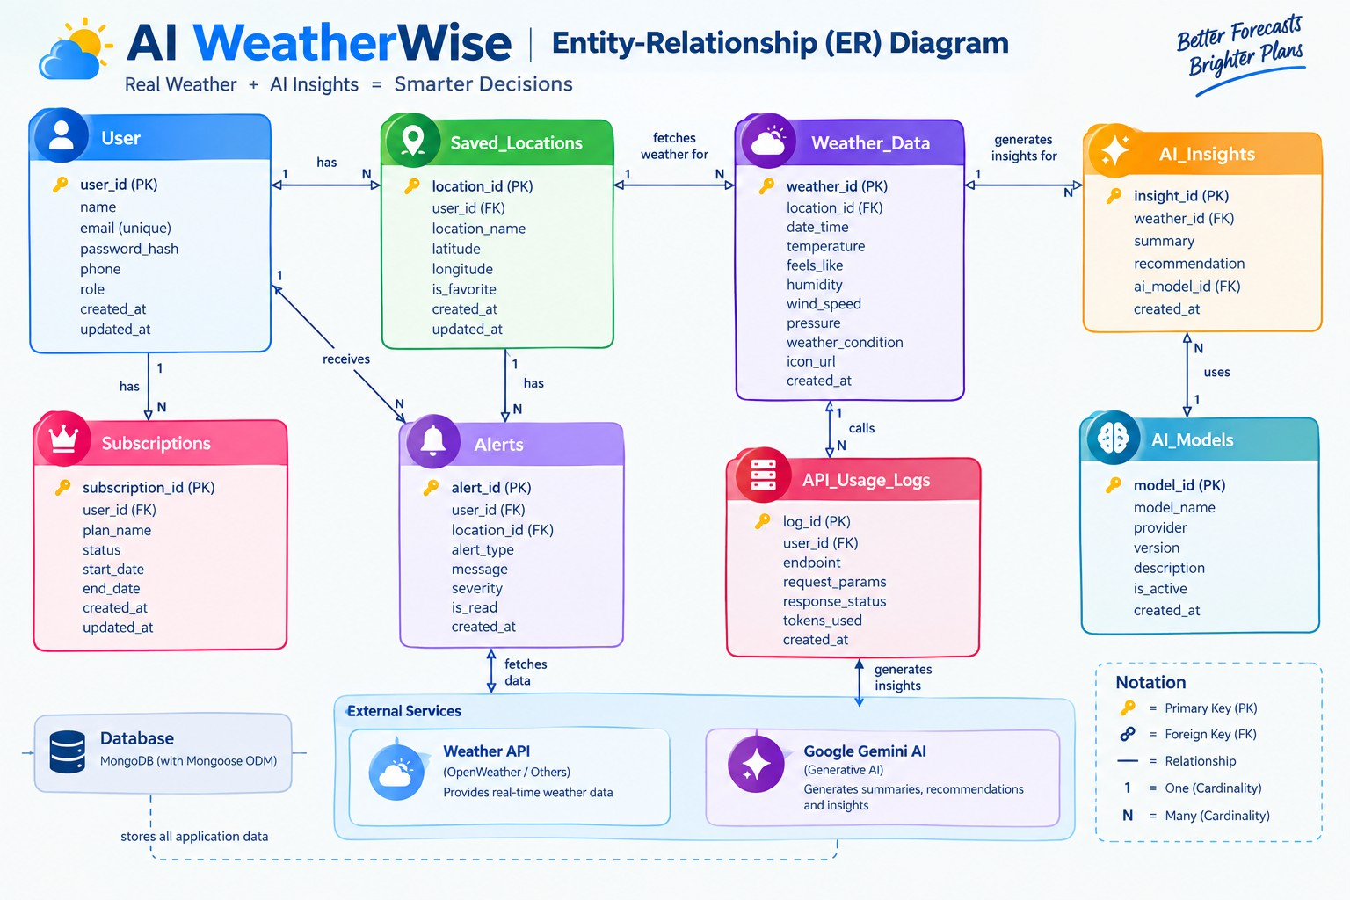

User Entity
  - _id: Unique identifier for each user (Primary Key – ObjectId)
  - name: Stores the user's name (String, Required)
  - email: User's email address (String, Required, Unique)
  - password: Stores the encrypted/hashed user password (String, Required)
  - role: Defines the user's access type, with "reader" as the default role (String)

Location Entity
  - _id: Unique identifier for each saved location (Primary Key – ObjectId)
  - user: Links the location to the corresponding user (Foreign Key – User Collection)

  - city: Name of the selected city (String, Required)
  - country: Country associated with the selected location (String, Required)
  - createdAt: Records when the location was added (Date, Default: Current

Date/Time)

Key Structural Mappings
  - User to Location (One-to-Many): One registered user can store and manage multiple favorite weather locations. Each saved location is associated with its respective user through the user reference.

ER Diagram Explanation Features

Core Backend Features
  - User Registration – Allows new users to create an account.
  - User Login – Authenticates registered users using their credentials.
  - JWT Authentication – Secures user sessions and protected API endpoints.
  - Protected Routes – Restricts access to user-specific resources.
  - Middleware – Handles authentication, validation, and request processing.
  - CRUD API – Enables users to create, view, update, and delete their saved locations.
  - Favorite Location Management – Allows users to maintain a list of preferred cities.
  - Real-Time Weather Data – Retrieves current weather information for selected locations.
  - MongoDB Data Management – Stores user and location information using MongoDB and Mongoose.
  - Error Handling & Validation – Validates requests and manages API errors.

AI Features
  - Google Gemini AI Integration – Connects the application with Gemini for intelligent weather analysis.
  - AI Weather Summaries – Converts weather data into simple, understandable descriptions.
  - Intelligent Recommendations – Provides suggestions based on current weather conditions.
  - AI-Powered Insights – Analyzes environmental conditions and generates useful information.
  - Natural Language Responses – Presents weather information in an easy-to-understand format.
  - Personalized Weather Suggestions – Generates recommendations according to the selected location's conditions.

Roles and Responsibilities

Admin
  - Manage Users – Monitor and manage registered user accounts.
  - Monitor API Services – Check the availability and operation of weather and AI services.
  - Monitor System Activity – Review application operations and backend activity.

  - Manage Database Operations – Maintain the reliability and consistency of stored user and location data.
  - Configure System – Manage backend settings and service configurations.

User
  - Register/Login – Create an account and securely access the application.
  - Manage Favorite Locations – Add, view, update, and remove saved cities.
  - Fetch Weather Data – Request current weather information for selected locations.
  - View Weather Information – Access temperature, humidity, wind, and other available weather metrics.
  - Request AI Insights – Generate AI-based weather summaries and recommendations.
  - Manage Personal Data – Maintain their account information and saved location preferences.

User Flow
- User logs in or registers.
- User saves a favorite city via the API.
- User fetches current weather metrics for that city.
- User requests AI-driven insights (summaries/recommendations) based on the weather data.
- System validates JWT and returns the requested information.

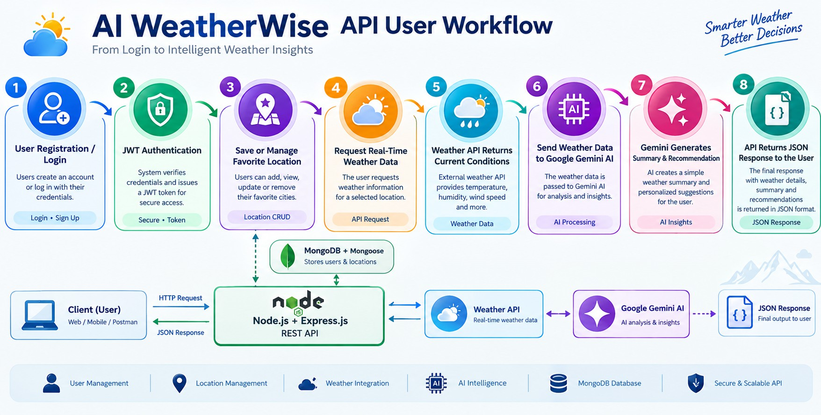

MVC Pattern
The backend follows the MVC (Model-View-Controller) architecture.

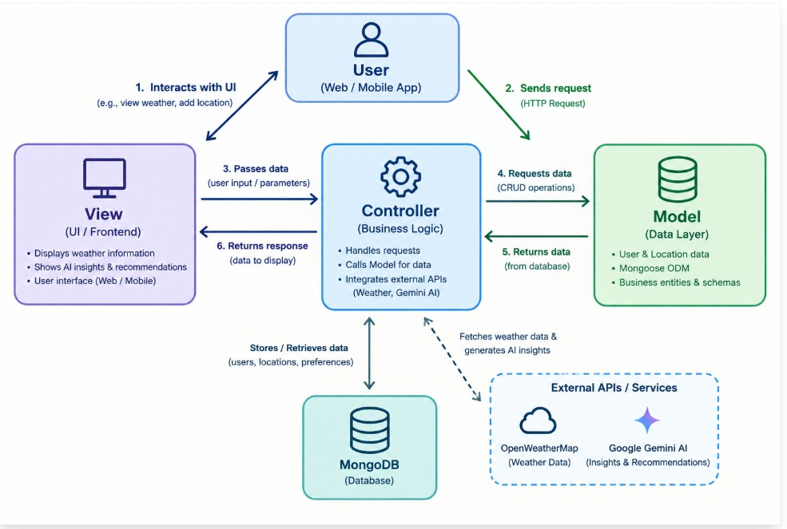

Model Layer (Data Blueprint)
Defines structure blueprints via strongly enforced Mongoose schemas mapping explicit fields into raw collection items inside MongoDB. It sets default states, indexing rules, and transformation parameters before validation persistence occurs.

Controller Layer (Execution Matrix)
The intermediary brain of the ecosystem. It captures request vectors from the execution routes, checks structural request constraints, delegates processing workflows directly to models, and packages the resultant output into standard JSON return arrays.

View Layer (Routing Network Interface)
In this pure headless backend service context, standard user-interface template views do not exist. Instead, the interface layer lives as an API Routing Layer. It links network requests on specified paths directly to their associated controller handler logic maps.

View Layer (Routes)

Authentication Routes
- User Registration
- User Login
- JWT Authentication
- Protected Access

Weather Routes
- Get Current Weather
- Retrieve Weather by Location
- Get Real-Time Weather Information

Location Routes
- Add Favorite Location
- View Saved Locations
- Update Location
- Delete Location

AI Routes
- Generate Weather Summary
- Generate Weather Recommendations
- Retrieve AI-Powered Weather Insights

User Routes
- View User Profile
- Update User Information
- Manage Account Details

Alert Routes
- Create Weather Alert
- View Alerts
- Update Alert Status
- Delete Alerts

Advantages of MVC
- Separation of Concerns
- Better Maintainability
- Easy Scalability
- Reusable Components
- Team Collaboration
- Easier Testing

Project Setup and Configuration

Creating the Project Folder

- Create a new folder named AI Weatherwise
- Open the project folder in Visual Studio Code.
- Initialize the project using Node.js and install the required dependencies.

Project Initialization
Open the project folder in the VS Code terminal and execute:
npm -v

Install Nodemon for development
npm install --save run dev

Create the Following Files
- index.js
- .env
- package.json

Create the Following Folder Structure
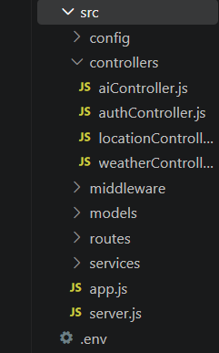

Environment Configuration
Create a .env file in the project root and configure the required environment variables.
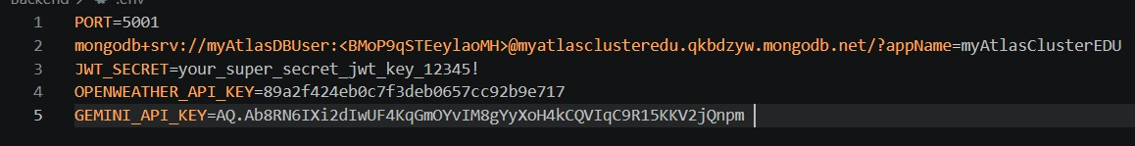

Backend Development
The AI WeatherWise backend is built with Node.js, Express.js, and MongoDB, using a modular and organized architecture. The system divides its functionality into separate components such as routes, controllers, middleware, models, services, and utility modules. This structure makes the application easier to develop, maintain, test, and scale. The backend provides secure REST API endpoints for user authentication, favorite location management, real-time weather data retrieval, and AI-based weather summaries and recommendations through Google Gemini.

Backend Structure:
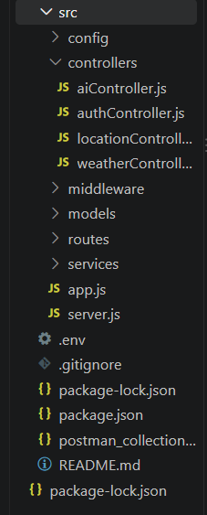

Core System Script Implementations

1. Application Entry Point (index.js)
The index.js file serves as the main entry point of the application. It initializes the Express server, loads environment variables, configures middleware, establishes the MongoDB connection, registers API routes, and starts the server after a successful database connection.

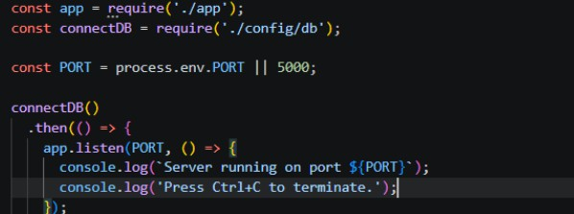

Create Database connection:
Now, make sure the database is connected before performing any of the actions through the backend. The connection code looks similar to the one provided
below

Mongoose Schema Definitions

Location Schema:

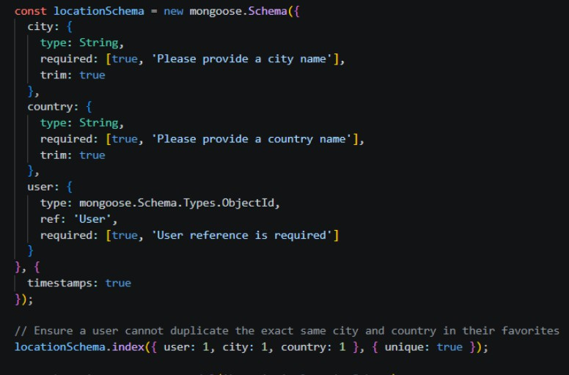

User schema:
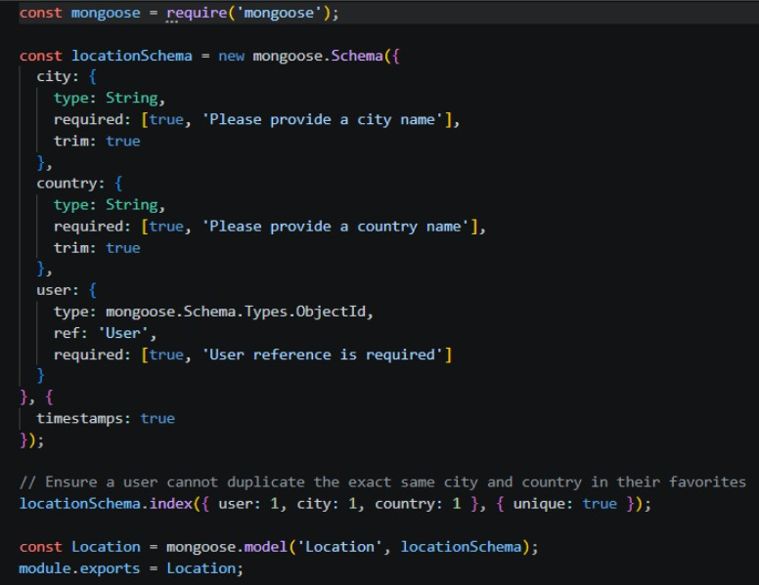

Project Execution

Step 1: Backend
The AI WeatherWise backend application can be started on a local computer using the Node.js runtime. Before launching the application, MongoDB must be available and all necessary configuration values should be defined in the environment file. Once the backend is started, it provides RESTful API services that can be accessed and verified through tools such as Postman or Thunder Client.
Running the Backend Server
Install the project dependencies required for the backend:
npm install
Start the backend application using the following command:
npm start
Once the startup process is completed successfully, the application establishes a connection with MongoDB and begins accepting client requests through the configured API endpoints.

API testing: Register API:

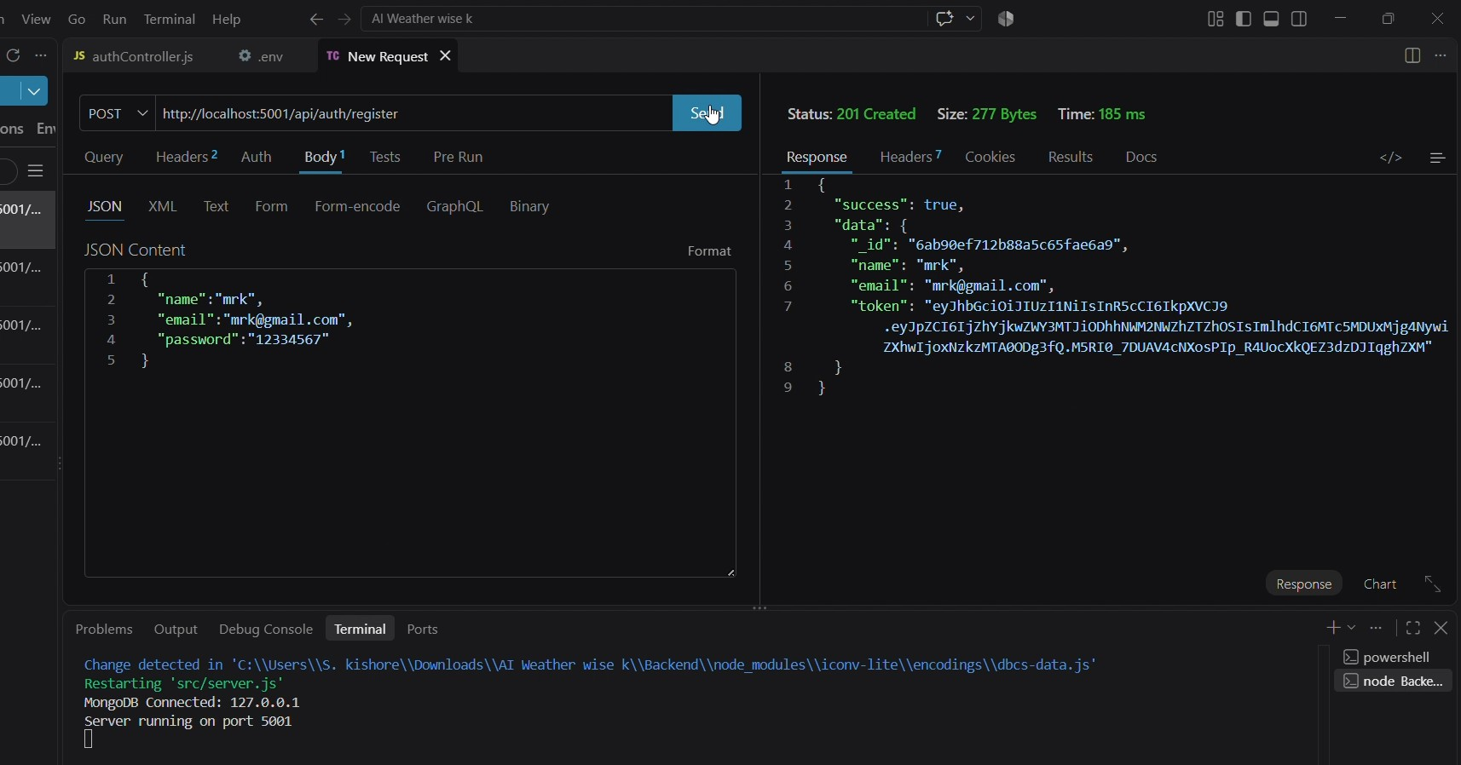

Explanation:
The Register API is used to create a new user account in the AI WeatherWise system. In the Thunder Client request, the user details such as name, email, and password are provided in JSON format. After clicking Send, the server processes the request and returns a 201 Created status with success: true. The response also contains the newly created user ID and an authentication token, confirming that registration was completed successfully.

Login API:
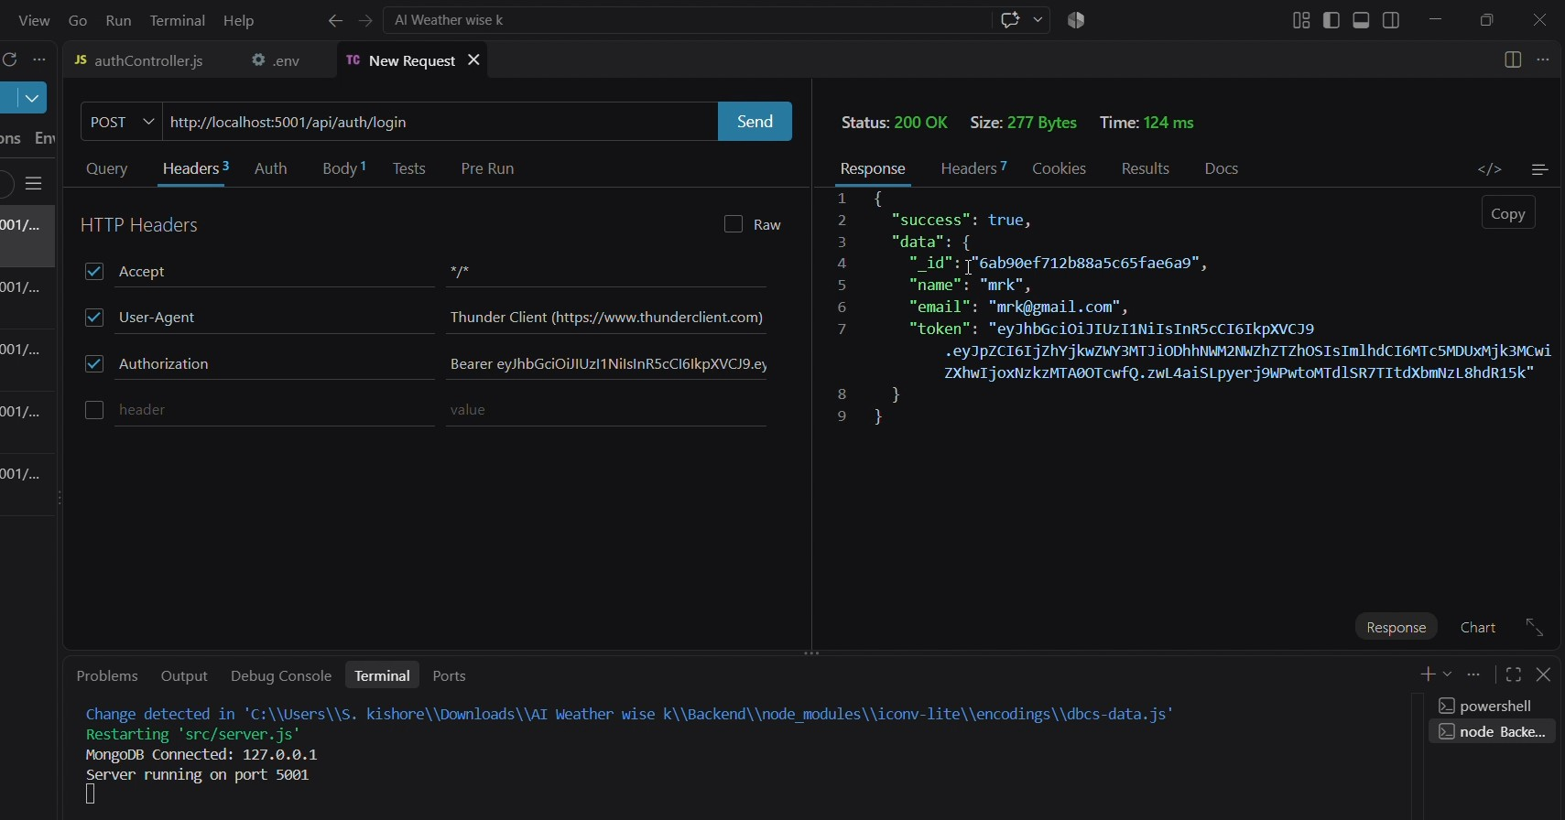

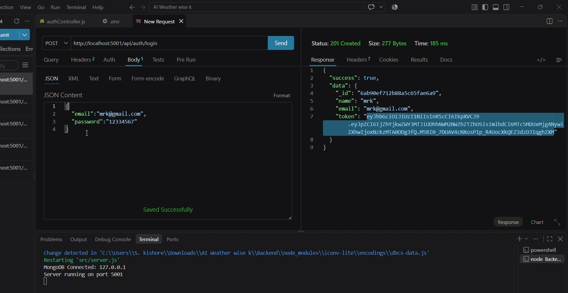

API Login Explanation:

The Login API allows an existing user to authenticate using their registered email address and password. The credentials are submitted to the /api/auth/login endpoint through a POST request. The successful response displays 200 OK, along with the user's details and an authentication token.The Login API allows an existing user to authenticate using their registered email address and password. The credentials are submitted to the /api/auth/login endpoint through a POST request. The successful response displays 200 OK, along with the user's details and an authentication token.

Weather API:

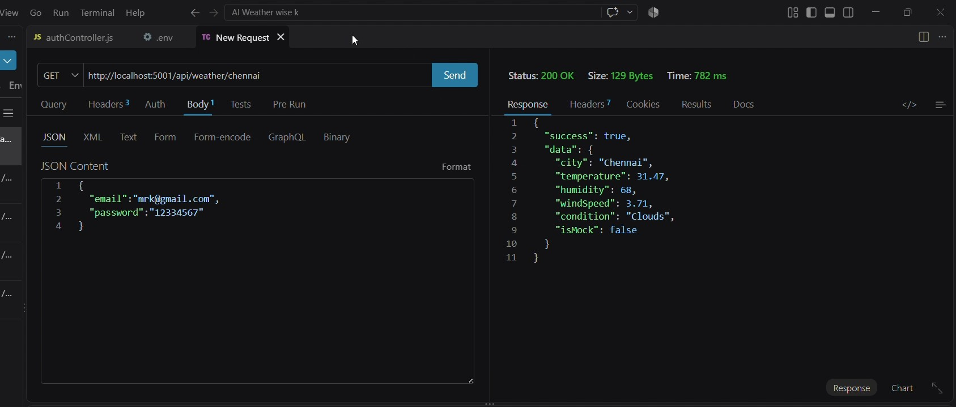

API weather Explanation:
The Weather API retrieves the current weather information for a selected city. In the screenshot, the endpoint /api/weather/chennai is requested using the GET method. The server returns weather information including the city name, temperature, humidity, wind speed, and weather condition. The response shows 200 OK, indicating that the weather request was processed successfully.

API Summary:

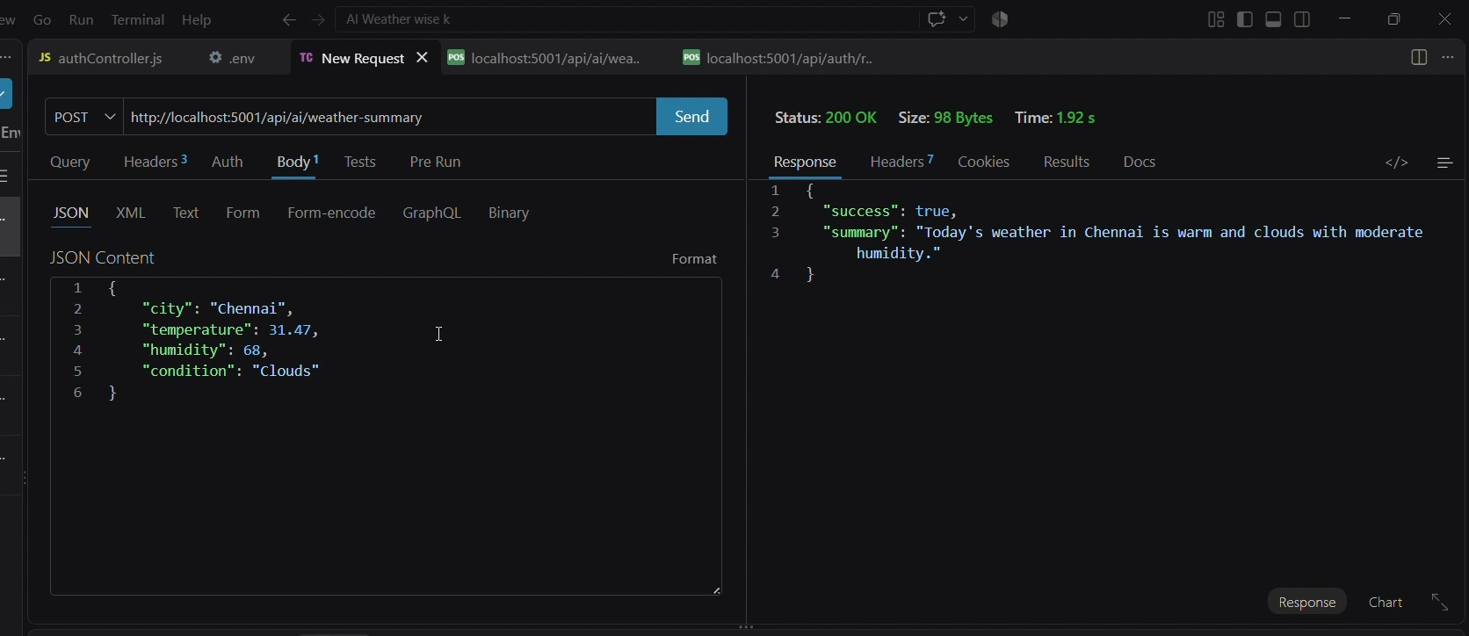

Explanation:
The AI Weather Summary API converts weather data into a simple natural-language description. The request contains information such as city, temperature, humidity, and weather condition. The API processes these values and returns an easy-to-understand weather summary.

Recommendation API:

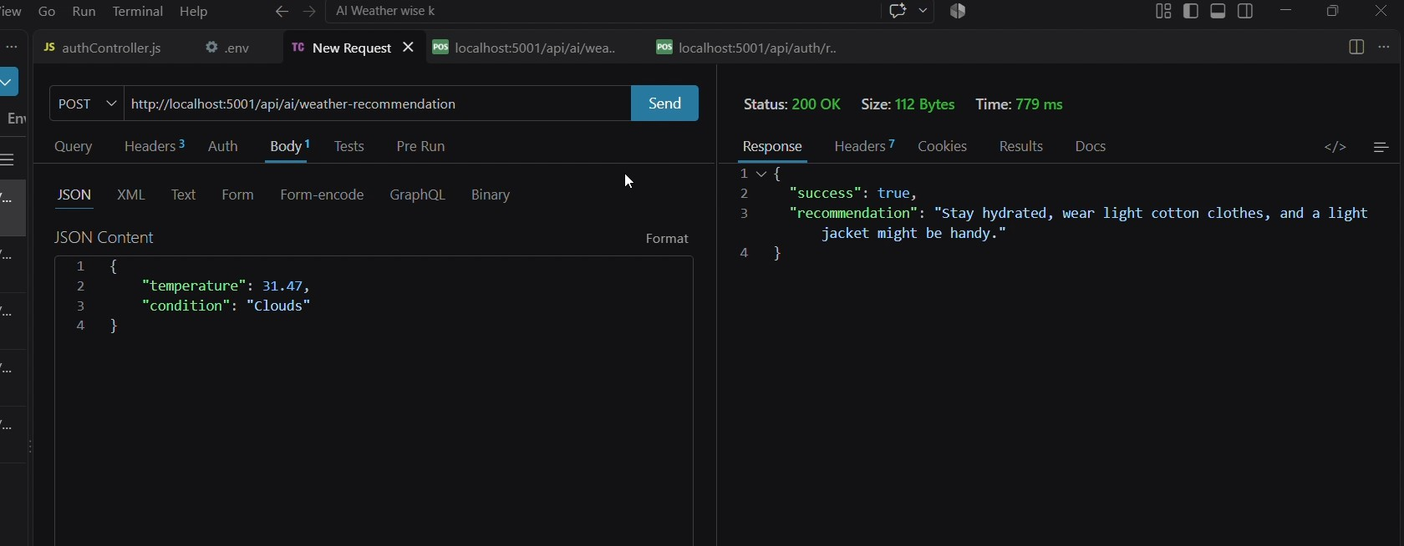

Explanation:
The Recommendation API generates weather-based suggestions using the provided environmental information. The request contains the current temperature and weather condition. After processing the data, the API returns a personalized recommendation for the user. The screenshot shows a 200 OK response with a recommendation related to hydration and suitable clothing.

Demo Video Link
https://drive.google.com/file/d/1ouT5TRJaKV8EQ1F2zW6bdFtZhFh20-mr/view?usp=drivesdk

Source Code Drive Link
https://drive.google.com/drive/folders/1Foi6nmgUT3sRQ3rkMB-70C3jNoDkVyLh?usp=drive_link

